India Power Shortage Thesis — Oct 2026 Update
Updated Nov 8, 2026 (first published Oct 31, 2026) · @Nikhil

Update, 8 November: demand stays hot, the coal rebuild stalls, summer power reprices again
The first week of November, from the same primary sources. The November demand and coal-path numbers here replace those in the 31 October sections below.
- Demand is running hotter than my November base. 1–7 November averaged 4.74 BU a day, +18% on the same week last year; I had +10% for the month. October closed at 159.76 BU (+21.9%), in line with my 159.7 estimate. With Diwali today and the 2023 analogue (Diwali on 12 November) pointing to a mid-month dip, I raise November to 138 BU (134–142) from 136.
- The coal rebuild has stalled. Plant stocks have gone sideways for ten days: 20.6 MT on 6 November against 21.9 MT on last week's base path. Deliveries beat my assumption (2.62 MT a day against 2.55), but burn is running at 2.58 MT a day, not the 2.37 I modelled. The reason is hydro: output was 35% below last year in the first week, against my −25%. Critical plants: 88 of 191.
- Supply is responding, just not enough. Coal India's October production rose 19.3% to 67.2 MT and offtake 18.7%; captive and commercial mines produced 22 MT, up 42%. That holds deliveries near 2.6 MT a day, but with weaker hydro and slightly more coal burned per unit the arithmetic now gives ~24 MT at end-November (was 26) and ~40 MT at end-March (was 46; range 34–50 for deliveries of 2.55–2.68 MT a day).
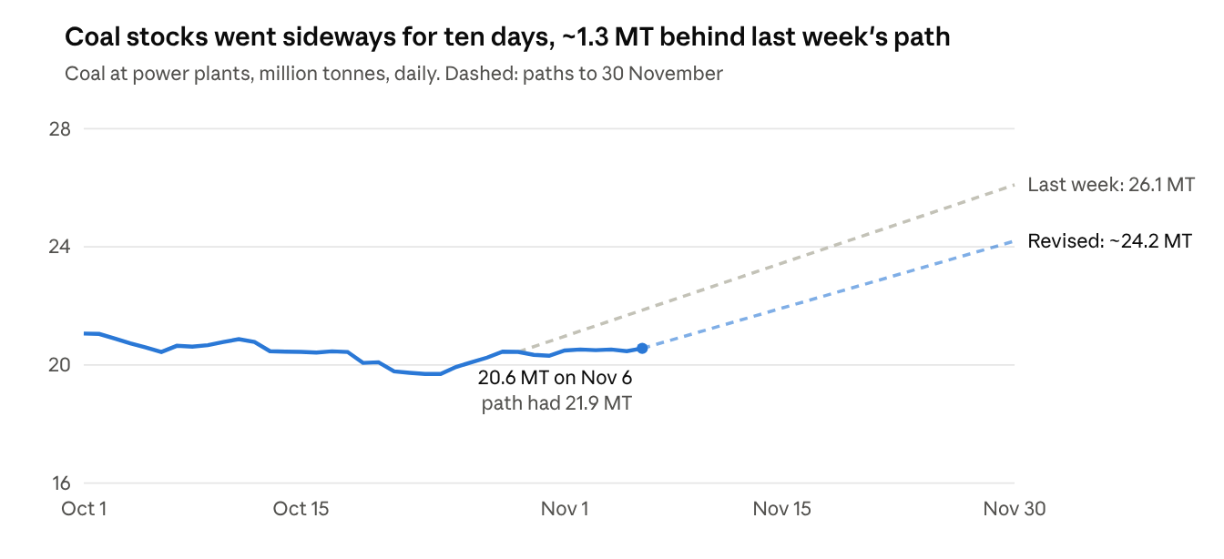
CEA daily coal stock reports, 1 October to 6 November 2026; paths from this note's coal balance
What I said to watch | What happened
Official October demand, ~159–160 BU | 159.76 BU, +21.9%
Coal India October production up 8% or more | +19.3% (67.2 MT); offtake +18.7%
IEX: does scarcity cap traded volume? | In day-ahead, yes: volume −3.8% while prices rose 149%. Real-time volume +23.7%; total 13.1 BU, +16.5%
Coal deliveries of ~2.6 MT a day; 26 MT by 30 November | Deliveries 2.62 MT a day, but burn 2.58: 20.6 MT on 6 November; 30 November now ~24 MT
Tamil Nadu retender (6 November) | Its regulator cleared February–July 2027 volumes for 6pm–midnight: 2,880 MW in February, 2,000 in March, 3,200 in April and May, 2,000 in June and July. Results not yet published
GERC orders on GUVNL RA/62 and RA/86 | None as of 7 November
Markets: spot eased, the summer forward did not. IEX day-ahead prices averaged ₹4.50/kWh so far in November (₹6.66 in October), with buy bids 0.85× sell bids — seasonal relief from lower post-October demand and the Diwali week. The forward market kept climbing: Noida Power's 5 November auction paid ₹12.0–12.7/kWh for April–June 2027 round-the-clock power, against ₹9.9–10.3 at GUVNL and KSEBL a week earlier, and even round-the-clock now fills only partly (60 MW and 30 MW of the 200 MW sought for April and May). It drew no bid at all for 200 MW of April–September evening power (19:00–23:00). AEML paid ₹10.22 for November–April round-the-clock power.
Hydro and weather got worse. CWC's 5 November bulletin has reservoirs at 66.0% of capacity, 27% below last year and 17% below normal; southern reservoirs are at 42.6% against 90% a year ago. IMD's November outlook (31 October) has below-normal rain (under 77% of normal) nationally and in the south, above-normal temperatures over most of the country, and "very strong El Niño conditions". Weaker southern storage trims the summer hydro assumption by about another gigawatt, which leaves the base-case night-peak gap at ~10–11 GW.
Batteries: first sign of slippage. A 65 MW / 130 MWh GUVNL storage project (Phase VII) missed financial closure, its developer citing force majeure from the West Asia war. On 6 November GERC declined to stop GUVNL encashing the performance guarantee but let the developer buy an extension. The project is small, but the base case counts on storage roughly doubling by April, and this is the first regulatory evidence of contracted storage running late.
Net: the thesis is a notch stronger than a week ago. The coal leg I had marked weaker is not easing as fast as October's data suggested, reservoirs are falling further behind, and the forward market is still repricing summer 2027 upward. The spot relief is seasonal.
New sources: Grid-India daily reports, CEA daily coal report, 6 November, CWC bulletin, 5 November, IMD November outlook, GERC order on IA 85/2026, DEEP results, Coal India October output, captive and commercial output (ANI), IEX October (Business Standard), Tamil Nadu summer procurement plan (DT Next).

Verdict: the thesis holds, but the risk has moved from coal stocks to the summer evening peak
October confirmed the shortage — demand +21% to ~159.7 BU, 328 MU unserved, evening gaps up to 5.8 GW — and then showed where it goes next. Three numbers decide it:
- 20.4 MT of coal at plants on 29 October: 33% of the norm and less than half of last year's 47 MT, with 92 plants critical. The slide has stopped, so the coal question is now the pace of rebuild — ~46 MT by March at ~2.6 MT a day of deliveries, but only ~23 MT if deliveries slip back to last winter's pace.
- ~10 GW short at the May 2027 night peak in the base case (from a 10 GW surplus to a 36 GW gap across scenarios): the requirement grows ~12 GW, firm supply ~2 GW, reservoirs are low, and El Niño is now forecast to last through April–June.
- 35% of the April–May 2027 evening power that discoms sought on DEEP found sellers, while summer RTC re-priced from ₹5.76 (August) to ₹9.87–10.34 (late October).
What changed since the last update: October demand beat my forecast (159.7 vs 156 BU), and coal bottomed on forecast. The rebuild path is now higher (46 vs 40 MT by March) because deliveries are running ~0.15 MT a day ahead, so the coal leg of the thesis is weaker than it was. The summer leg is stronger: El Niño is expected to persist into the pre-monsoon, and the forward market is both pricing and rationing evening power. The main risks to the call are deliveries, batteries and a policy turn on gas.

October scorecard: demand beat, the coal slide stopped, prices more than doubled
Demand ran ahead of my forecast and the early-October evening shortfalls faded once the northeast monsoon set in on 15 October. Coal stocks landed on forecast and turned up in the last week of the month. Sources: Grid-India daily reports for 1–30 October (31 October estimated at 4.7 BU), CEA daily coal reports to 29 October, IEX market data.
 | Last forecast | Actual | Read
October demand | 156 BU (+18%) | ~159.7 BU (+21%) | Beat by ~2%; 1–30 October alone was 155.0 BU
Peak demand | — | 260.7 GW on 5 October | October 2025: 210.7 GW
Unserved energy | — | 328 MU, on 19 of 30 days | October 2025: 10 MU. Evening shortfall peaked at 5.8 GW on 3 October and stayed under 0.4 GW after 18 October
Coal stock at plants | 20 MT on 31 October (19.5–21) | 20.4 MT on 29 October | Low of 19.7 MT on 23–24 October; a year earlier 47.2 MT
Critical plants (under 25% of norm) | Peak near 96 | Peaked at 100 on 21 October; 92 on 29 October | Out of 191 plants CEA tracks
Deliveries vs burn | First run of deliveries above burn | 25–29 October: 2.68 vs 2.53 MT a day | October average 2.64 vs 2.68
IEX day-ahead price | — | ₹6.66/kWh | October 2025: ₹2.67. Real-time market ₹5.77
What sat underneath, per day against October 2025:
- Coal did the work: coal generation +27%, hydro −26% (−34% in the last week), wind −14%. Solar +61% now covers daytime growth, but not the evening.
- Maintenance was deferred to keep units running: generator outages averaged 40 GW against 70 GW a year earlier. Rajasthan's state generator told its regulator it had postponed annual overhauls. That buys output now at the cost of reliability later.
- The late-October cooling was weather, not a turn in the trend: the last two weeks still ran +18–20% year on year, flattered by Diwali (20–21 October 2025) and Cyclone Montha's rain in last year's base.
- A sellers' market on the exchange: day-ahead buy bids were 2.5× sell bids in October (0.3× a year earlier), yet cleared volume fell 3.5%. The ₹10 price cap rations rather than clears.

Demand forecast: growth cools to 3–10% as last year's soft base drops out
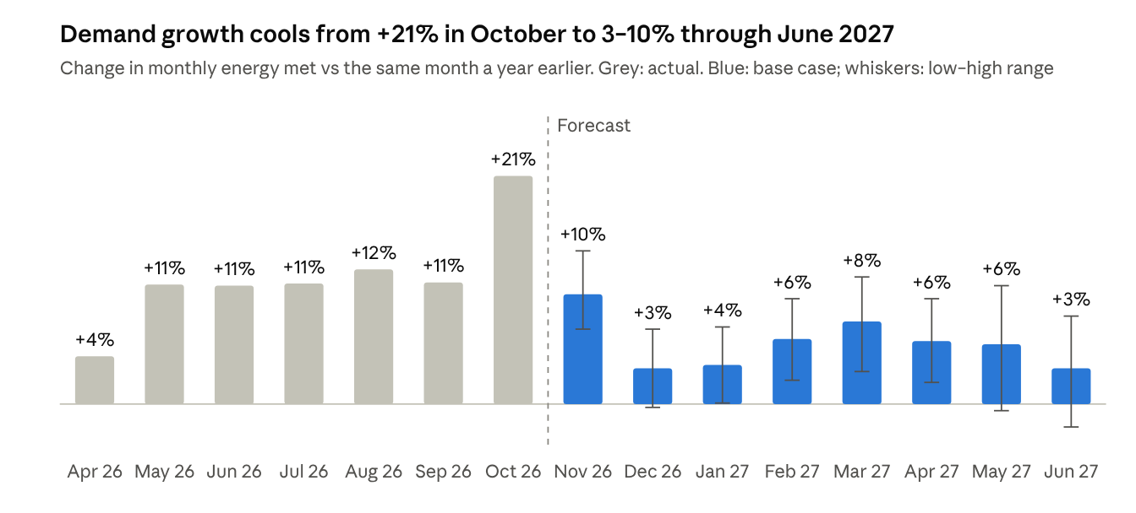
Grid-India daily reports, April 2025 to October 2026 (31 October estimated); forecasts are this note's base case
Base case: FY27 demand of ~1,876 BU (+9.4%), with April–October already +11.6%. November–March totals 729 BU — the same as my last forecast (730 BU) but re-shaped — and this is the first pass at April–June 2027.
Month | Last forecast (BU) | New base (BU) | Low–high (BU) | What drives it
Nov 26 | 135 | 136 | 132–141 | Late-October run-rate +18–20% year on year; Diwali moves into November (8 November); heavier rabi pumping after a monsoon at 87% of normal
Dec 26 | 145 | 143 | 138–148 | Warm El Niño winter against December 2025's strong finish (241 GW on 31 December)
Jan 27 | 146 | 148 | 143–153 | January 2026 set the 245 GW winter record; irrigation offsets a milder winter
Feb 27 | 140 | 141 | 136–146 | Soft base: February 2026 grew 1%
Mar 27 | 164 | 161 | 154–167 | Early heat as El Niño decays; March 2024, the last such year, grew 9%
Apr 27 | — | 163 | 157–169 | Trend growth plus heat; April 2026 already left 270 MU unserved
May 27 | — | 174 | 164–183 | IRI puts El Niño odds at 92% for April–June, so a hot pre-monsoon is the base case
Jun 27 | — | 172 | 163–180 | Monsoon-onset risk: El Niño odds are still 60% for May–July
How it is built: three cross-checks per month — growth on the year-ago month; the late-October run-rate (4.83 BU a day) scaled by the seasonal shape of the 2023-24 and 2024-25 winters; and two-to-three-year growth against normal-weather years (4–7% a year). The 2023-24 El Niño is the closest analogue: October 2023 jumped ~22%, then growth settled at 5–9% (January +6%, February +5%, March +9% on Grid-India data). That is why I do not extrapolate October's +21%.
Peaks: base summer-2027 peak of ~286 GW (278–295) against 270.8 GW in May 2026; the night (non-solar) peak ~268 GW (263–274) against 253 GW. CEA's adequacy plan put FY27 at 289 GW, 18 GW above what has materialised, so I do not anchor on official projections.

Coal: stocks have bottomed at ~20 MT; the rebuild hinges on holding 2.6 MT a day of deliveries
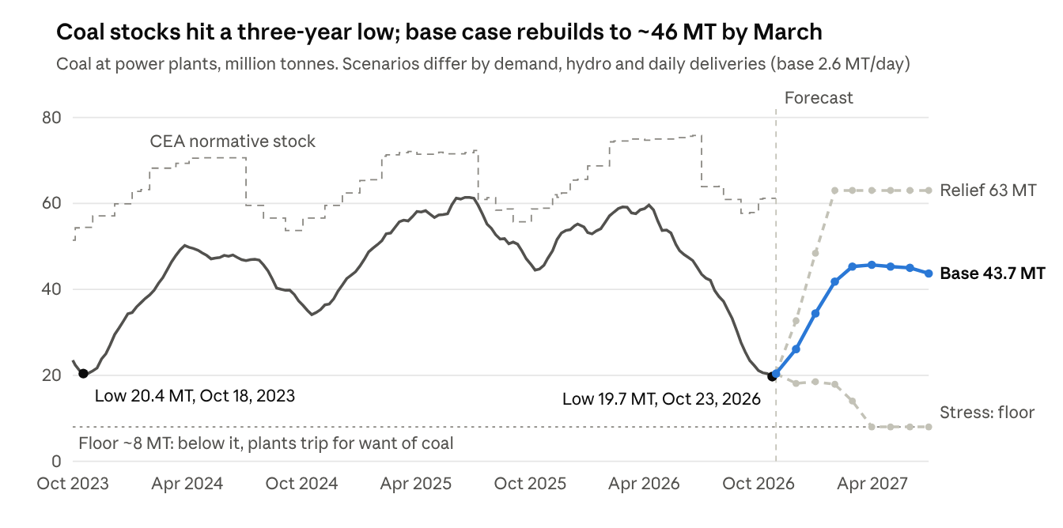
CEA daily coal stock reports, weekly, 1 October 2023 to 29 October 2026; scenarios from this note's coal balance
Stocks fell from 59 MT on 31 March to a 19.7 MT low on 23–24 October — less than half of last year's 47 MT — and have edged up since, with deliveries above burn every day from 25 to 28 October. October deliveries averaged 2.64 MT a day (September 2.36) on record rail loading (~470 rakes a day for power in early October; the railways' coal loading was up 22% year on year).
How the path is built: daily burn = the demand forecast, grossed up for auxiliary use, minus hydro, nuclear, gas, lignite and renewables, times the coal used per unit (0.64–0.67 kg/kWh in winter, calibrated to CEA's reported consumption). The method reproduces October's 3.91 TWh a day of coal generation and 2.68 MT a day of burn. Renewables +30% year on year in winter and +25% in summer, hydro −25% through March and −15% after, nuclear +20%. Base deliveries: 2.55 MT a day in November (Diwali and Chhath in the coal belt), then 2.60–2.62. Relief adds 0.08 MT a day and stops building at the norm; stress takes 0.10 off and pairs it with high demand and low hydro.
The answer swings on deliveries, because the stock change is a small gap between two big flows:
Average deliveries, November–June | End-March stock | End-June stock
2.45 MT a day (last winter's pace) | 23 MT | 7 MT
2.55 MT a day | 38 MT | 31 MT
2.60 MT a day (about October's pace) | 45 MT | 43 MT
2.65 MT a day | 53 MT | 55 MT
2.75 MT a day | 61 MT, at the norm | at the norm
Base demand, hydro and renewables throughout. Each 0.05 MT a day moves end-March stocks by ~7.5 MT. Under the stress demand case, holding 30 MT into June needs ~2.74 MT a day.
Revisions against my last forecast: 30 November 24.5 → 26 MT, 31 December 30 → 34 MT, 31 March 40 → 46 MT. Deliveries are running ~0.15 MT a day above what I had assumed. Part of that came from Coal India drawing down its own pithead stock (H1 FY27 offtake 384 MT, +7.6%, against production of 321 MT, −2.5%), so winter supply now rests on the production ramp (September output +9.2%), not on stock already used.
Plants in the coverage on 29 October (stock as a share of CEA's norm):
- JSW Energy: Mahanadi (1,800 MW) 16%, receiving 12.6 kt against 27 kt burned — about three days of coal; Utkal (700 MW) 15%; Ratnagiri (imported coal) 161%.
- Tata Power: Mundra UMPP (4,000 MW, imported coal) 161%, about 40 days in hand; Trombay 53%; Haldia 37%; Prayagraj 25%; Jojobera 19%; Maithon 16%.
- Adani Power: Kawai 3%, Raipur 7%, Mundra III 9%, Tiroda 10%, Mundra I–II 22%, Udupi 50%.

Hydro, wind and weather: El Niño now looks set to run into the 2027 summer
- El Niño: NOAA's Climate Prediction Center (8 October) expects a strong-to-very-strong El Niño through January–March 2027 (over 83%) and gives 83% odds of a historic event in October–December. IRI (19 October) has the weekly Niño-3.4 reading at +3.3°C and El Niño odds of 100% through March–May 2027, 92% for April–June and 60% for May–July; neutral only becomes the likelier state in June–August (51%).
- What that means for demand: a warm, dry winter trims heating load in the north but raises pumping for rabi crops — Rajasthan's distribution companies expect 1.8–3.3 GW morning gaps from November to February. Summers after strong El Niño peaks — 1998, 2010, 2016, 2024 — brought severe Indian heat, so a hot April–May is my base case. A 60% El Niño chance in May–July raises the risk of a late or weak monsoon onset, which is June 2027's swing factor.
- Reservoirs: CWC's 15 October bulletin had 178 reservoirs at 126.7 BCM, 68.6% of capacity — 24.5% below last year and 16.4% below normal — after a monsoon at 87% of normal. The south is worst: Pennar −72%, Cauvery −61%, Krishna −33% against normal.
- Hydro output: −26% year on year in October and −34% in the last week (318 against 484 MU a day). Storage hydro is the evening workhorse; I assume −25% through March and −15% in April–June, when Himalayan snowmelt props up run-of-river plants.
- Wind: −14% year on year in October, and on some October evenings Tamil Nadu's wind fell from ~3,000 MW to 10 MW. Wind decides summer nights: on 2026's top May night peaks it supplied 17–23 GW, but April nights went as low as 8 GW.
- Northeast monsoon: onset on 15 October. IMD expects normal October–December rain (88–112% of the long-period average) over the south peninsula with above-normal temperatures — some help for southern reservoirs, not a fix.

Summer 2027 evening peak: base case ~10 GW short at the May night peak
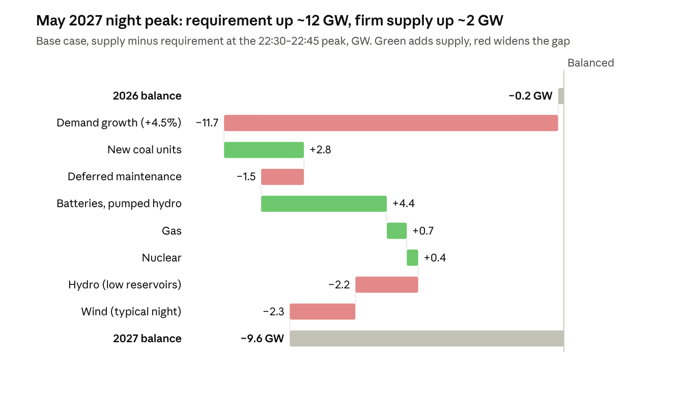
Grid-India 15-minute data, top May 2026 night peaks; 2027 assumptions as listed below
From April to July the hour that binds is the 22:15–22:45 night peak — air-conditioning load after the sun has set; from August to October it moves to 19:00–19:45. On the four highest May 2026 night peaks (19–22 May), Grid-India's 15-minute data show 252 GW met by ~185 GW of coal and lignite, 30 GW hydro, 20 GW wind, 8 GW gas, 7 GW nuclear and just 3.6 GW from storage. The highest coal output on the 2026 peak nights I checked was 189 GW (3 June). Unrestricted night-peak demand was ~256 GW (253 GW met plus ~3 GW of reported shortfall), roughly what was available — 2026 got through with almost no margin.
GW at the May night peak | Relief | Base | Stress
Night-peak demand growth | +2.5% | +4.5% | +7%
Requirement, incl. exports and pumping | 267 | 272.5 | 279
Coal and lignite | 192 | 190 | 184.5
Hydro | 29.5 | 27.5 | 25
Wind | 22 | 18 | 9
Batteries and pumped hydro | 11 | 8 | 6
Gas | 12 | 9 | 8
Nuclear and other | 10 | 10 | 10
Surplus (+) or gap (−) | +10 | −10 | −36
What goes into the base case:
- Coal: about 5 GW of units due between June 2026 and April 2027 (Ghatampur 3, Buxar 2, Udangudi 1–2, Yadadri 5, Mahan 3, Patratu 3) against a 7.3 GW FY27 target. FY26 delivered 74% of its target and the July–September quarter added just 0.8 GW, so I count +2.8 GW at the peak, and −1.5 GW for units that skipped overhauls this year. Stress takes a further 4 GW off for coal-short plants.
- Storage: about 9.1 GWh of batteries were operating by September, with ~3 GWh more due by December (CREA). Storage's contribution at the night peak rose from 3.6 GW in May to 5.5 GW by September–October; 8 GW assumes the fleet roughly doubles again by April.
- Gas stays near 2026 levels: the power secretary has said there is no gas obligation this year.
What would close a 10 GW gap: roughly 20 GWh more two-hour batteries than assumed; running the idle gas fleet on imported LNG under a government direction, as in summer 2024, at a high fuel cost (Tamil Nadu's gas-backed evening offers came in at ₹33–41); or moving demand out of the night peak. The cross-checks point the same way: Tamil Nadu projects a 5.5 GW evening-peak gap in April 2027, rising to 6.2 GW by September (SRPC operations committee, 9 October); GUVNL told GERC its peak gap runs 1.5–5.1 GW through March; and the forward market, below, cannot find evening supply for April–May.

Market signals: summer-2027 power has re-priced, and evening blocks are not finding sellers
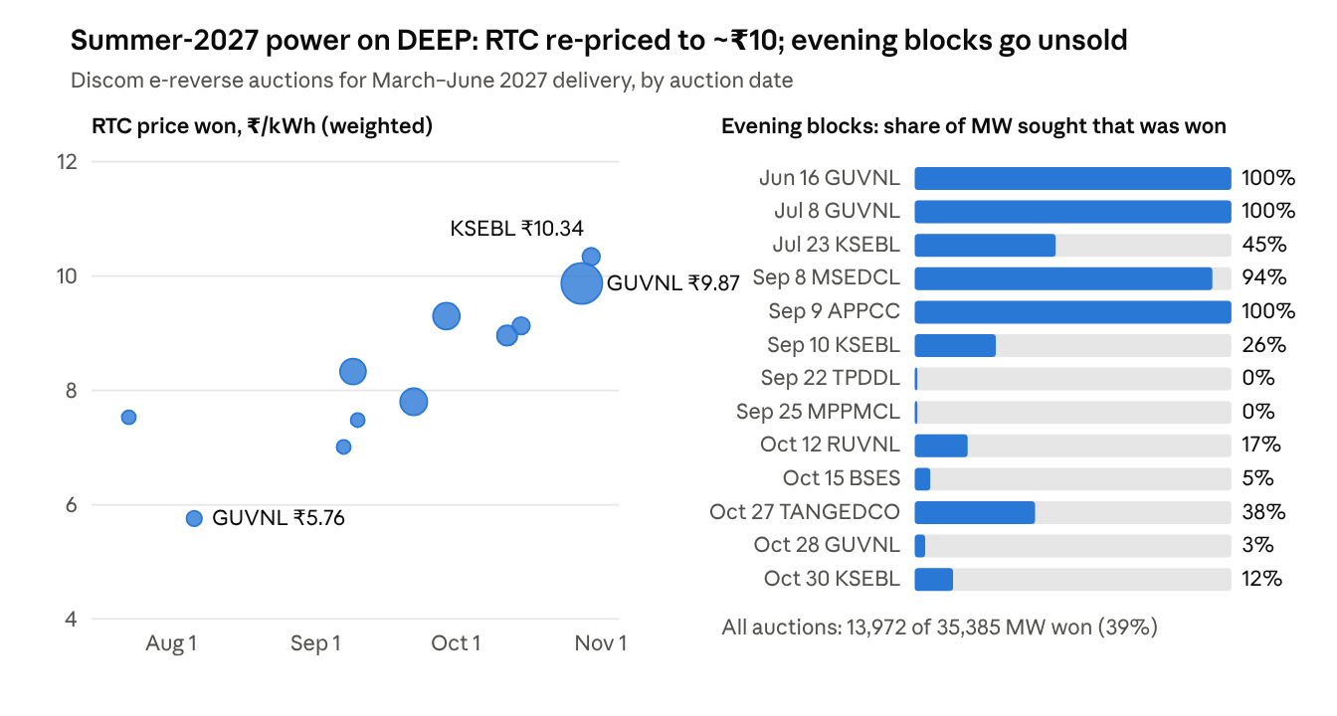
MSTC DEEP portal results for 40 discom short-term auctions in FY27 (pulled 31 October 2026); evening = blocks starting 17:00 or later
- DEEP, the discoms' short-term auction portal: round-the-clock power for March–June 2027 cleared at ₹5.76/kWh in GUVNL's 6 August auction. By late October GUVNL paid ₹9.87 for 4,900 MW (28 October) and KSEBL ₹10.34 (30 October). Evening blocks are the bottleneck: for April–May 2027 evenings, discoms sought 20.1 GW and won 7.0 GW (35%). Since mid-September most evening requisitions for April–May drew no bid at all (TPDDL, BSES, RUVNL, KSEBL), and GUVNL got 50 MW of the 1,500 MW it sought, at ₹35.
- Winter is tighter still: auctions held in May–July filled 83% of the November–February evening power sought, at an average of ₹12. October's auctions filled 6%, leaving aside Tamil Nadu's awards at ₹28–41.
- Caveat: these are auction results, not signed contracts. Tamil Nadu cancelled its 27 and 29 October awards (₹35–41.50 for evening power) as unviable and retenders on 6 November, and regulators can still decline to approve the rest.
- Exchanges: IEX's day-ahead market averaged ₹6.66/kWh in October (₹2.67 a year earlier) and ₹7.34 in September; buy bids were 2.5× sell bids, and cleared volume fell 3.5%. With a ₹10 cap (₹20 in the high-price segment), exchange prices understate scarcity: Rajasthan told its regulator that only ~10% of its September evening bids cleared, and ~5% in the high-price market.

Gujarat and Rajasthan: what the regulators have approved
Gujarat: GERC approves each GUVNL batch of DEEP purchases, and everything bought for delivery through March 2027 is approved. The first contracts for April–June 2027 (RA/86, 28 October) have no order yet. Rajasthan: RERC does not approve DEEP purchases one by one. On 29 October it ruled that emergency short-term buys need no prior approval under its resource-adequacy and tariff regulations, consented only to a single-bidder slot for November–December, and left the costs to true-up — where its benchmark rate is ₹4.59/kWh, so recovery of summer buys at ₹8–20 is not assured.
Purchase (auction date) | Delivery | Price, ₹/kWh | Status
GUVNL RA/23 (16 Jun) | Oct-26 to Mar-27 peaks, 490–1,200 MW | 9.98–12.54 | Approved, GERC order 2696/2026 (11 Aug)
GUVNL RA/32 (8 Jul) | Aug-26 RTC; Sep–Feb 17–20h peaks; Mar-27 18–24h | 6.07; 17.75–20; 9.96 | Approved, GERC 2685/2026 (30 Jul)
GUVNL RA/38 (6 Aug) | Oct-26 to Mar-27 RTC, 500–1,200 MW | 4.92–5.76 | Approved, GERC 2725/2026 (17 Sep)
Torrent RA/43 (7 Sep) | Nov-26 to Mar-27 RTC | 5.99–7.01 | Approved, GERC 2743/2026 (23 Oct)
GUVNL RA/62 (29 Sep) | Nov–Dec RTC, 875 MW | 8.59–9.49 | No order yet
GUVNL RA/86 (28 Oct) | Nov-26 to Jun-27 RTC, up to 1,500 MW | 8.98–10.16 | No order yet; GERC has taken 3–8 weeks
RUVNL RA/72, "TN-35" (12 Oct) | Nov–Dec peaks, 115 MW from one bidder (NVVN); Mar–Sep 2027 RTC and evenings | 9.49–9.99; RTC 8.43–9.05; evenings 16.35–19.76 | RERC consented to the single-bidder slots only (2450/2026, 29 Oct); the rest needs no prior approval, with costs checked at true-up
RUVNL from the Himachal government via PTC | Nov-26 to Feb-27, up to 1,300 MW | 15.50 (16.62 landed) | Approved as an exception, not a precedent (RERC 2451/2026, 29 Oct)

What would break the thesis
The evidence against is real: coal stocks have stopped falling, the October evening shortfalls faded once temperatures eased, and solar (+61% year on year) now covers daytime growth. These would turn the call:
- Deliveries hold at 2.65 MT a day or more through winter → stocks above 50 MT by March, and coal stops constraining summer output. Watch CEA's daily receipts and Coal India's monthly production.
- Winter demand fades the way it did in 2023 — after October 2023's jump, growth fell back to mid-single digits. My December–January base already assumes only 3–4%.
- A battery surprise — every extra 10 GWh of two-hour batteries commissioned by April adds ~5 GW at the evening peak. Mercom counted 8.2 GWh installed in the first half of 2026 alone.
- A gas U-turn — a Section 11 direction to gas plants with pooled LNG could add 5–10 GW at night. The power secretary has ruled out a gas obligation this year; a reversal would itself tell you how tight officials think the summer is.
- Wind and weather — a windy pre-monsoon, or El Niño fading faster than IRI expects.
- Load shifting — time-of-day tariffs and moving farm feeders to solar hours (PM-KUSUM). RERC has told Rajasthan's procurer to build a demand-flexibility portfolio.

What it means for the coverage
An analytical read-through of the data above, not a rating view.
- JSW Energy: short-term sales meet ₹9–10 RTC and ₹14–20 evening forwards for summer 2027, but Mahanadi and Utkal (2.5 GW) sit at 15–16% of normative coal, and Mahanadi burned twice what it received on 29 October. Volume is at risk until stocks rebuild; Mahanadi's November receipts are the tell.
- Tata Power: Mundra UMPP (4 GW, imported coal) holds 161% of its normative stock and runs under Section 11 to 31 December — the asset in the coverage best placed for scarcity prices. Haldia and Prayagraj sold GUVNL October–March RTC at ₹4.92–5.72 (GERC-approved), locked in below today's ₹9–10 forward. Tata Power-DDL bought summer-2027 RTC at ₹7.6–8.0 (passed through, at a working-capital cost), and Tata Power Trading is among Torrent's approved suppliers.
- PFC and REC: discoms are paying ₹9–41/kWh at the margin — Tamil Nadu's ₹37 evening power, Rajasthan's ₹15.50 bilateral. RERC benchmarks short-term costs at ₹4.59/kWh and leaves recovery to true-up, so the squeeze lands on discom cash first; watch generator dues on PRAAPTI and demand for working-capital loans. The supportive side: 44–48 GW of coal capacity under construction and a growing storage book (GERC's 28 October order on GUVNL's 450 MW / 900 MWh Phase IX battery tender).
- Adani Ports: the shortage has not become an import push — the blending mandate was shelved (reported 19 October) on cost. Upside is limited to imported-coal plants running harder; Adani Power's Mundra units at 9–22% of norm suggest imported coal is arriving just in time rather than being stockpiled.
- Premier Energies and Waaree: regulators are naming batteries and firm, dispatchable renewables as the fix (both RERC orders of 29 October), and ₹14–20 evening prices improve the economics of storage-linked solar. Supportive for module and cell demand, but it does not by itself change the domestic cell-capacity glut view.
- IEX: prices are up 2.5×, but day-ahead cleared volume fell 3.5% in October. Scarcity caps traded volume, and the price caps push buyers to DEEP and bilateral deals.

Watch list to December
When | What | What would matter
1–2 Nov | Official October demand (Grid-India, power ministry) | ~159–160 BU confirms the +21%
1 Nov | Coal India October production and offtake | Production up 8% or more keeps 2.6 MT a day of deliveries plausible
2–5 Nov | IEX October update | Whether scarcity keeps capping traded volume
6 Nov | Tamil Nadu retender opens: February–July 2027, 750–1,200 MW peak and 1,250–2,000 MW RTC | First summer-evening price after the ₹35–41 cancellations
8 Nov; 13–15 Nov | Diwali; Chhath in the coal belt | Dips in demand and in coal loading
12 Nov; ~19 Nov | NOAA ENSO update; IRI forecast | Any shortening of El Niño into spring
Mid-November | Coal India Q2 results | Pithead stock (my estimate ~68 MT at end-September)
November–December | GERC orders on GUVNL RA/62 and RA/86 | First regulator view on ₹9–10 summer-2027 RTC
Thursdays | CWC reservoir bulletin | Southern storage after the northeast monsoon
Daily | CEA coal receipts vs burn | Base case needs ~2.6 MT a day: 26 MT by 30 November, 34 MT by 31 December
31 Dec | Section 11 directions for captive coal plants and Tata's Mundra expire | An extension would signal officials see the summer as tight

Sources
Primary data and documents opened for this update:
- Grid-India daily PSP reports — 1,306 daily spreadsheets, April 2023 to 30 October 2026: energy, peaks, shortages, generation by source, 15-minute night-peak mix
- CEA daily coal stock report, 29 October 2026 — and 550 earlier daily reports from April 2025
- IEX market snapshot — day-ahead and real-time monthly prices and bids
- DEEP portal results (MSTC) — 40 FY27 discom auctions
- GERC orders on petitions — 2685, 2696, 2725 and 2743 of 2026
- RERC order 2450/2026 and RERC order 2451/2026, both 29 October 2026
- NOAA CPC ENSO diagnostic discussion, 8 October 2026 and IRI ENSO forecast, 19 October 2026
- IMD northeast monsoon outlook, 1 October 2026
Secondary sources used for specific points:
- CWC reservoir bulletin of 15 October, summarised by Insights IAS
- CREA quarterly snapshot, Q2 FY27 — storage, thermal additions
- Thermal additions and FY27 target (Power Peak Digest, from CEA)
- Mercom battery installations, H1 2026 (pv magazine)
- CEA adequacy plan, FY27 peak of 289 GW (Mercom)
- Coal Ministry on October drawdown (PSU Watch)
- Coal India H1 FY27 production and offtake
- Blending mandate shelved (Nation Path, citing Bloomberg)
- Tamil Nadu deficit forecast and cancelled tenders (DT Next) and DT Next editorial on ₹37 evening power
- Business Standard: 98 plants critical, 25 October
- Jefferies FY27 demand view (Awaz The Voice)

